Title
Author1ª, Author2^{b}, Author3^{c}…..
ª Institution 1; ^{b} Institution2; ^{c}Institution 3.
E-mail: mariobrossi@hotmail.it

Abstract must fit in one page (less than 300 words, see recommendations below).
Text (time, 11 pts) and Figures (tiff, jpeg..)

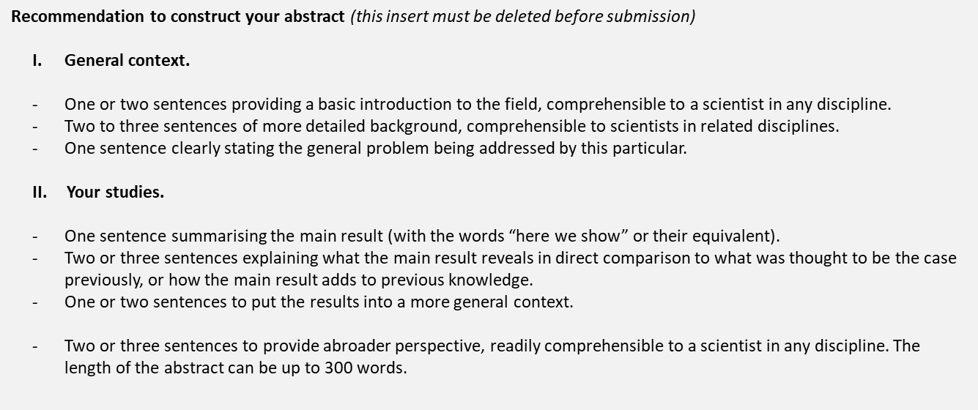

1. N. Surname, ; Journal, 2004, 104, 1201-1217.
2. N. Surname, N. Surname2, …………….., Journal, 2009, 25(10), 5467–5475.
3.
4.

